NaijaSense AI Solution Paper
DSN × Bluechip Tech LLM Agent Challenge · DSAS 2026

Team: TAOTECH SOLUTIONS

Abstract
NaijaSense AI is a dual-task, stateful LLM system for Task A (review + rating simulation) and Task B (personalized recommendation ranking). The core differentiator is silent history retrieval by user_id before generation, followed by persona merge with current user inputs. The stack combines a role-split model strategy (fast router + strong generator), retrieval-augmented review generation, optional critique-regenerate quality control, and a deterministic recommendation scorer with explainability traces.
The system ships with a production-style hub (/unified) that includes single-response UX, live NDJSON reasoning timeline, safety advisories, language control (English/Pidgin/Yoruba mix), health pre-warm status, and thumbs feedback logging. Results show LLM generation is the strongest quality lever for Task A, while Task B ranking remains interpretable but weak on hard same-domain distractors; the next step is LLM reranking on top-K candidates.

1. Problem and Goals
Online reviews encode behavior: tone, rating bias, domain preferences, and context sensitivity. Most baseline systems underperform because they treat users as static profile fields and hide their reasoning.
The system design emphasizes:
- Faithful personalized review simulation (Task A)
- Explainable recommendation ranking (Task B)
- Nigerian context readiness
- Reproducibility and honest reporting
Design constraints: output diversity, reasoning transparency, and low-latency/low-cost deployment.

2. System Overview
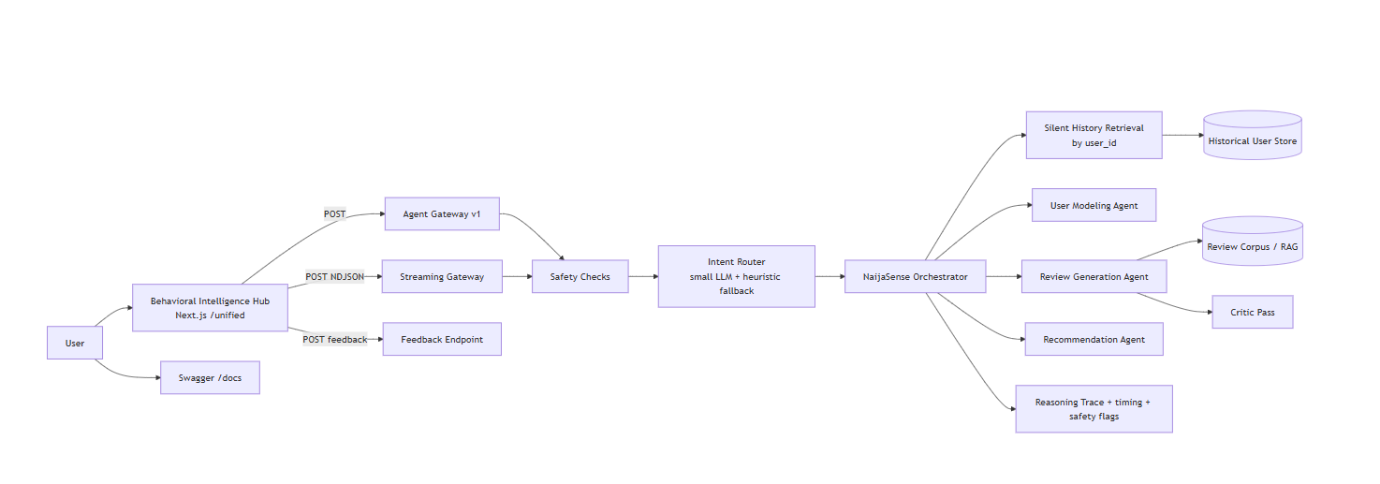

2.1 Role-split model strategy
- Router role (llama-3.1-8b-instant): intent routing, persona inference, critique scoring.
- Generator role (llama-3.3-70b-versatile): review text generation only.
This keeps cost low while preserving quality where it matters most.

2.2 Silent context retrieval (core differentiator)
For every request, the system runs a pre-LLM step:
- Pull up to five past records for user_id.
- Build HistoricalPersona (avg_rating, rating_tendency, tone_signal, top domains/interests).
- Merge with UI persona fields using default-vs-override logic.
- Log provenance in reasoning metadata.
Unknown users fall back to current input signals.

3. Task A: Review + Rating Simulation

3.1 Generation approach
We use a facts-in, prose-out prompt contract:
- Input: item, domain, user persona, optional context.
- Retrieval: top-3 related reviews from corpus as style/concreteness references.
- Guardrail: explicit “do not copy facts from retrieved examples.”

3.2 Diversity controls
To avoid repeated outputs on identical requests, generation uses per-call seed, tuned sampling (temperature, top_p, presence/frequency penalties), and anti-template prompt rules.

3.3 Critique-regenerate pass
A low-cost critic scores review specificity (1-5 rubric). If below threshold, the system regenerates with explicit issue prompts. Most outputs pass in one shot, keeping cost low.

3.4 Language and local context
Output modes:
- english
- pidgin
- yoruba_mix
This supports local contextualization without forcing slang into formal outputs.

4. Task B: Personalized Recommendation

4.1 Deterministic hybrid ranker
Task B ranking is intentionally deterministic and auditable. Score combines:
- interest overlap
- memory overlap
- context overlap
- domain alignment
- rule-based boosts (cold-start, cross-domain, query intent)
- penalties for placeholder-like candidates
The conversational summary is LLM-generated but does not alter ranking order.

4.2 Multi-turn behavior
A per-user rolling buffer is threaded into Task B requests. Previous turns influence ranking signals and are surfaced in explainability outputs.

5. Product Surface and Observability
The Behavioral Intelligence Hub is part of the solution quality, not only a demo shell.
Key shipped features:
- Single-response UX (no duplicate compare outputs)
- Live reasoning timeline from /api/agent/v1/stream
- Backend status pill with pre-warm health check
- Routed-task and latency chips
- Safety advisory badges (safety_flags)
- Thumbs feedback to JSONL (/api/agent/feedback)
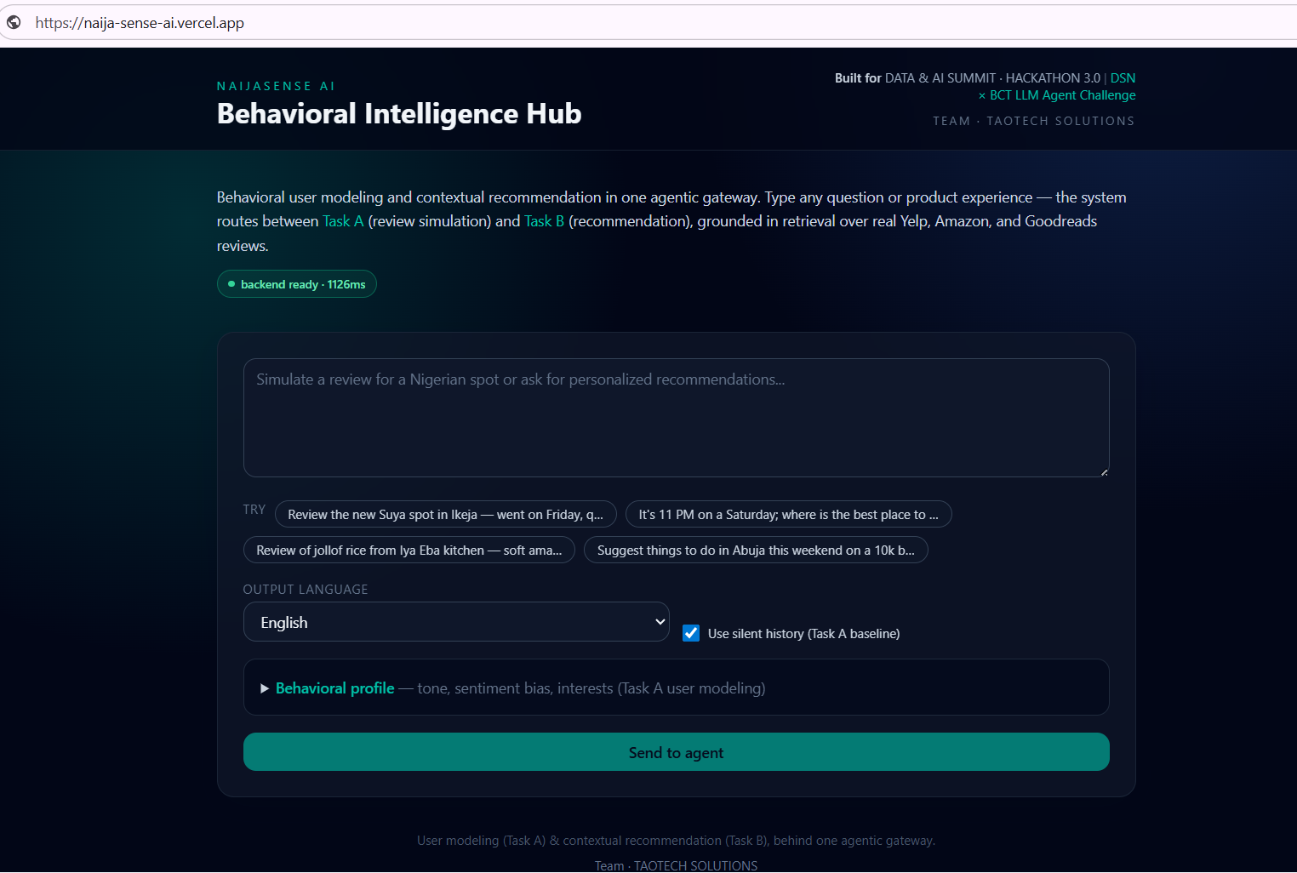
Figure 1. Home screen (homescreen.png): initial view shown after opening https://naija-sense-ai.vercel.app/ https://naija-sense-ai.vercel.app/, including quick prompts, language selector, and status indicator.
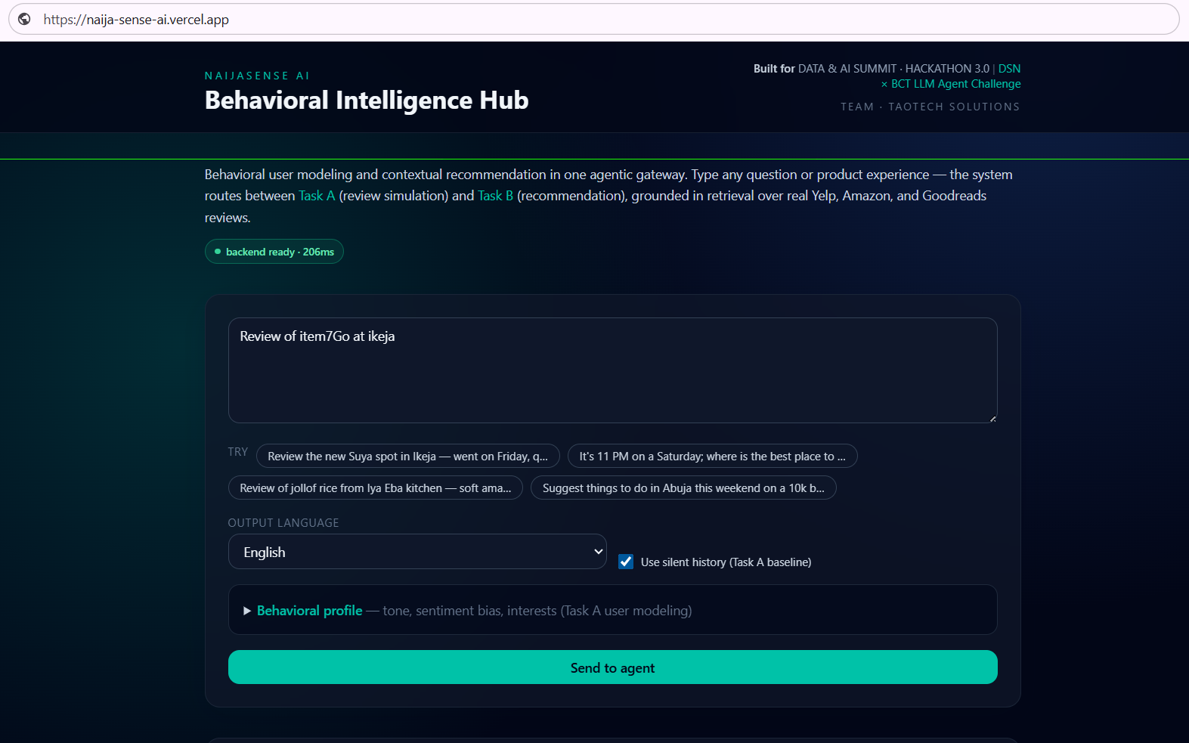
Figure 2. Input workflow (input.png): the interaction step where the user enters query, persona context, and language before submitting to the gateway.
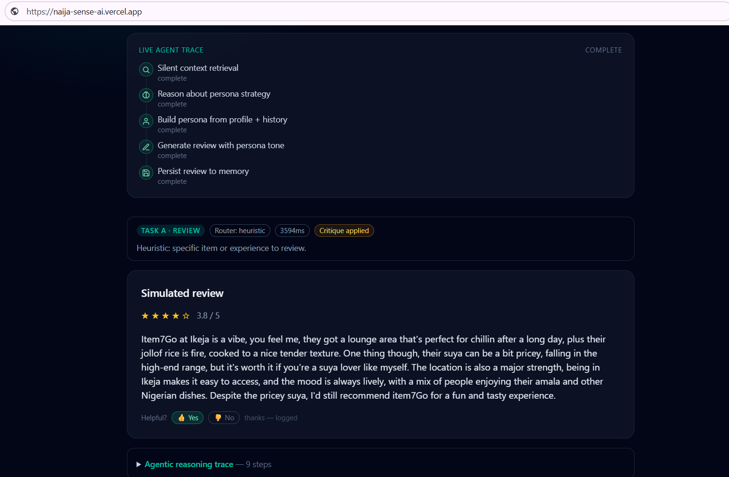
Figure 3. Output view (output.png): result card after inference, showing routed task, generated content, safety advisories, and reasoning trace.
The UI flow is: Figure 1 (entry) -> Figure 2 (input) -> Figure 3 (output).

6. Experiments and Findings

6.1 Ablation setup
Variants:
Variant | Disabled component
Full rag | none
no_rag | retrieval examples removed
no_critique | critique-regenerate off
no_llm | generation via deterministic fallback only

6.2 Task A results

Variant | ROUGE-1 ↑ | ROUGE-L ↑ | Token-F1 ↑ | RMSE ↓
full | 0.161 | 0.104 | 0.128 | 1.251
no_rag | 0.187 | 0.109 | 0.129 | 1.003
no_critique | 0.165 | 0.102 | 0.132 | 1.240
no_llm | 0.126 | 0.086 | 0.123 | 1.242

Interpretation: LLM generation is the strongest quality lever (largest drop in no_llm), RAG can lower lexical overlap while improving concreteness, and critique mainly improves qualitative quality.

6.3 Task B results
Variant | NDCG@10 | Hit Rate@10
full | 0.062 | 0.20
no_rag | 0.062 | 0.20
no_critique | 0.062 | 0.20
no_llm | 0.062 | 0.20

Random baseline on this hard set is higher for Hit Rate@10 (~0.50), revealing a ranking gap.

6.4 Behavioral-fidelity A/B
scripts/eval_fidelity.py runs paired tests with and without history (include_history=true/false) and compares rating error, token similarity, and tone match. This isolates the contribution of silent context retrieval.

7. Reproducibility
Environment: Python 3.11+, pip install -r requirements.txt, and .env from .env.example.
Run stack:
docker compose up --build
Core endpoints: http://localhost:8000 (API), http://localhost:8000/docs (Swagger), http://localhost:3000/unified (Hub UI).
Evaluation: python scripts/run_real_benchmark.py --all_variants and python scripts/eval_fidelity.py.

8. Limitations and Next Steps
- Task B reranking: deterministic scorer needs LLM reranking over top-K to handle subtle same-domain distractors.
- Metric depth: token-F1 fallback may be used where BERTScore installation is constrained; full semantic metrics should be run in a compatible env.
- Data coverage: Amazon slice was smaller than intended in our benchmark run due to external data endpoint availability.
- Safety robustness: regex safety layer is practical but not exhaustive; learned safety critics can improve recall.
- Feedback learning loop: thumbs data is logged; next step is periodic distillation into adaptive few-shot banks.

9. Conclusion
NaijaSense AI delivers a practical, auditable, and locally contextualized dual-task agent for review simulation and recommendation. The strongest contribution is a measurable stateful workflow: silent history retrieval, persona merge, and transparent reasoning traces visible both in API outputs and in the live hub.
Task A quality is competitive and diverse; Task B explainability is strong but ranking on hard distractor sets requires LLM reranking. The system is reproducible, observable, and ready for iterative improvement.

